1. **Introduction**
2. **Theoretical Background**
   1. **Economic Considerations**

For the economic considerations of this product we compared it to established pre-existing products. Our goal was to add a new of functionality to one of these products while not exceeding the cost of the other, more robust platform. We choose to expand upon a set product to ease the development of the mechanical side of the project.

The two product being evaluated are the Dunn rite pool cleaner, our expansion platform, and the Solar Breeze NX, our product to beat. The Dunn Rite system has a cost of 112$, whilst the Sea Breeze cost around 646$. This gives us a comfortable of 534$ margin in materials and other considerations to develop our product.

Utilizing the Appendix {*} we enumerated all of the additional components we utilized in our design. Adding all the costs together we found that we stayed within boundaries of our limitations.

* 1. **Health Considerations**

This product brings benefits to the health of its users since it is constantly cleaning out impurities from the surface of the pool. This impurities can contain bugs, leafs, dirt, hair and other contaminants collected on the surface. Aside from themselves containing germs, they can also attract scavengers like birds and lizards to come and feed on the contaminants. These can leave other germs and even defecate on the pool.

All of these factors degrade the quality of the swimming water and can affect the health of its users. To keep the quality at a safer level we also include a cleansing tablet holder you can passively distribute cleansing product. Utilizing these two measures we can make sure the water stays at an acceptable swimming level while not invading into services provided by professional pool cleaning surfaces.

* 1. **Ultrasonic sensor**

To measure distance to the pool borders and obstacles we are utilizing three ultrasonic JSN-SR04 sensors. The sensors have waterproof receivers and transmitters that allow us to safely detect the obstacles without frying the circuits. These are located on the cardinal points of the ship, one looking left, the other right, and one monitoring the objects on the front.

To interface with them we had to take hardware considerations and we developed a driver code that allows us to determine how far an obstacle is. For the hardware we supplied power to it using the 5V regulator. The trigger pin that sends the signal works at the 3.3v level, however the echo pin that sends the signal to the micro works at 5V. To fix the logic mismatch we utilized a voltage divisor.

The algorithm works by sending a ping to all three sensors, this triggers an ultrasonic wave of a certain duration to come out of the sensors. The wave ounces off neighboring obstacles and returns to the receiver. Calculating the duration of the new wave you can calculate the distance that the object is. The formula for this is: {*}

This has a minimum threshold of {*} inches, were you can measure distance farther from that point accurately.

* 1. **Magnetometer**

To make sure that we stay on the desired path we will utilize a magnetometer. This works as a compass that gives us a direction towards magnetic north. This direction will be given in {*} format.

Using this we can take an initial measurement to orient ourself within the pool and compare the current orientation towards this bias.

* 1. **Relay H-Bridge**

To control our movement we will utilize two independently controllable DC motors. For this we will utilize an H-Bridge configuration utilizing relays. We utilize this configuration since the relays can isolate the noise generated from the motors to the micro and it comes with the stock Dunnrite product, saving us in cost. The setbacks are that the motor cannot switch directions as quickly, which shouldn’t be an overall problem.

Since the relay motor rivers take up too much current for the microcontroller to use we add an additional 2N2222 transistor to amplify the current. In the the current consumption to the micro is around 2.45mA whilst the dc motor current is 200mA. This measurements are without load. With load{*}

The schematics for the H-Bridge are given in Appendix {*}. Here we see the micro pin connections motorA, and motorB. Utilizing these pins we can get the following functional table to describe the functionality of the motors.

|  |  |  |
| --- | --- | --- |
| Motor A – 1 | Motor A – 2 | Direction |
| 0 | 0 | Stopped |
| 0 | 1 | Forwards |
| 1 | 0 | Backwards |
| 1 | 1 | Force Stop |
| *Table {*} Motor A direction based on input* | | |

|  |  |  |
| --- | --- | --- |
| Motor B – 1 | Motor B – 2 | Direction |
| 0 | 0 | Stopped |
| 0 | 1 | Forwards |
| 1 | 0 | Backwards |
| 1 | 1 | Force Stop |
| *Table {*} Motor B direction based on input* | | |

By simply sending the direction to the pins via GPIO pins we can enable the motors.

1. **WaveX Autonomous Pool Cleaning System Design**
   1. **Block Diagram**



*Figure {*} System Block Diagram*

* 1. **Component Breakdown**

Power Systems:

* Power Source – The power is provided by a 9.6V, 2100mAh Ni-MH battery.
* Power regulators – The power is reduced from 9.6V to 5V and 3.3V utilizing two LM317 linear voltage regulators with their appropriate configurations.
* Battery monitor circuit – This is utilized to measure the voltage of the battery, if it drops below 8V (1.0V per pack), we stop the vehicle to prevent damage.

Motor System:

* H-Bridge Driver – The control of the motors is done utilizing a relay H-Bridge. This is explained in detail on the theoretical background.
* Motor 1&2 – Dc motors that are connected to the propellers of the system.

User Interface:

* Notification LEDS – Sends information to the user about local information. This includes the status of the Bluetooth connection, the status of the system, if it has enough battery, and the current operating mode.
* Buzzer – A 5V buzzer that beeps if the tray is full.
* Mode Switch – Hardware toggle switch that determines the operational mode of the boat. The mode can be overwritten utilizing the control application.
* Power Switch – Turns the system on or off.

Sensors:

* AK8963 Magnetometer – This reads the positions of magnetic north and sends the data to the Microcontroller. It is contained within the MPU9250 IMU and accessed via I2C protocol.
* JSN – SR04 – ultrasonic sensor to determine distance to obstacles.

Communication:

* Phone application – This is an external control application that controls many aspects of the boat. It has the ability to manually control the boat, select the operational mode, and check the status of the battery.
* HC-06 – This Bluetooth module that receives and sends information to the external control application.
  1. **Calculations**
     1. **Voltage regulators**

The voltage regulators are connected according to figure {*}, here everything stays the same except for the Resistors R1 and R2. We modify this values according to the formula provided in the datasheet [7]:

$$V_{o}=1.25(1+\frac{R2}{R1})$$

$$R2= R1\left(\frac{V_{o}}{1.25}-1\right)$$

Instead of utilizing R2 = 240Ω we changed it to a similar value 200Ω and based our calculations on that. Utilizing this ratio we created two different regulators, one for 3.3V and one for 5V, the calculation for R2 for each is below.

For 3.3V:

$$R2= 200\left(\frac{3.3}{1.25}-1\right)=328Ω$$

For 5V:

$$R2= 200\left(\frac{5}{1.25}-1\right)=600Ω$$

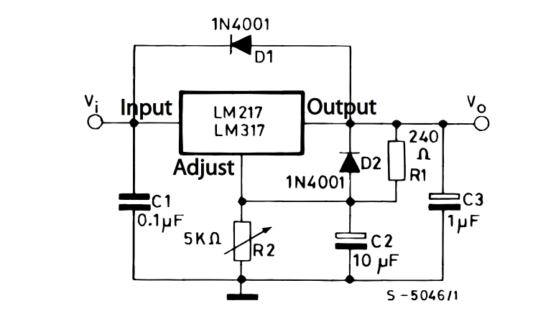

*Figure {*} LM317 voltage regulator with protection diodes*

* + 1. **Battery Monitor Circuit**

This circuit is described in figure {*}, it contains two main functional blocks, an enable consisting of an NPN transistor and a voltage divisor to lower the voltage of the battery bellow the reference level. We also included a buffer so that we don’t induce loading into the circuit.

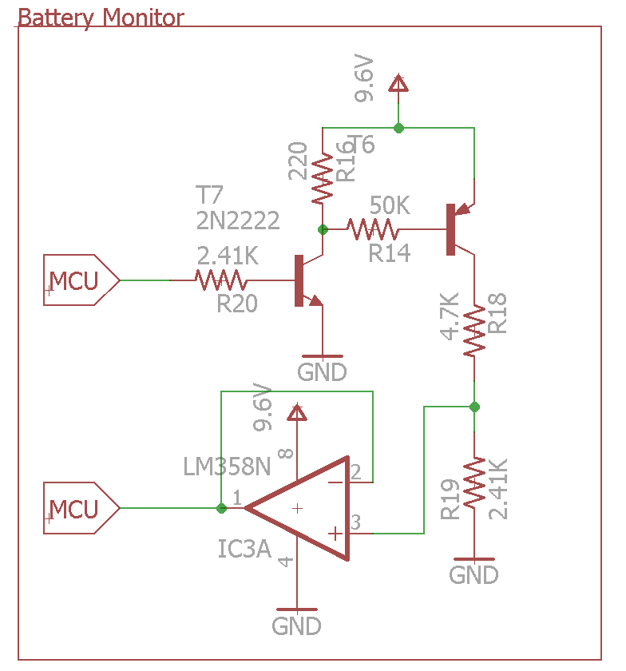

*Figure {*} Battery monitor circuit*

The calculations are as follows.

Voltage Divisor:

$$3.3vref=\frac{R19}{R18+R19}\left(9.6v-0.2v\right)$$

From MCU:

$$I_{mcu}= \frac{3.3v-0.7v}{2.41K}=1.07 mA$$

Current from 9.6V source:

At Voltage divisor:

$$I_{batt}= \frac{9.6v-0.2v}{2.41K+4.7K}=1.32mA$$

At enable configuration:

* + 1. **H-Bridge Driver {*}**

The circuit in figure {*} depicts the wiring of a single H-Bridge unit. Here L1 represents the load of the dc motor, and K3 represents the internal current of the relay switching coil.

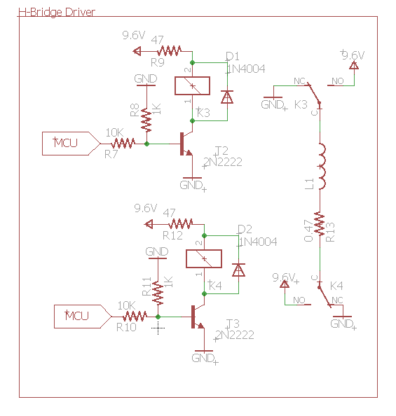

*Figure {*} H-Bridge motor configuration*

For the case were we have no load the motors consume 200mA

The coil has a switching current of 80mA D[1], this means that the MCU alone isn’t enough to power it completely. For this reason we utilize a 2N2222 transistor D[2] to amplify the current. We assume that the transistor is working at saturation so we utilize the DC gain (30) from the datasheet to calculate the current emitting from the MCU.

* + 1. **Configurations LEDs**

This LEDS are utilized to notify the user of certain changes in the system. There are a total of three different colors, blue, green and red, however since the green and red contain similar characteristics so we omit their individual calculations.

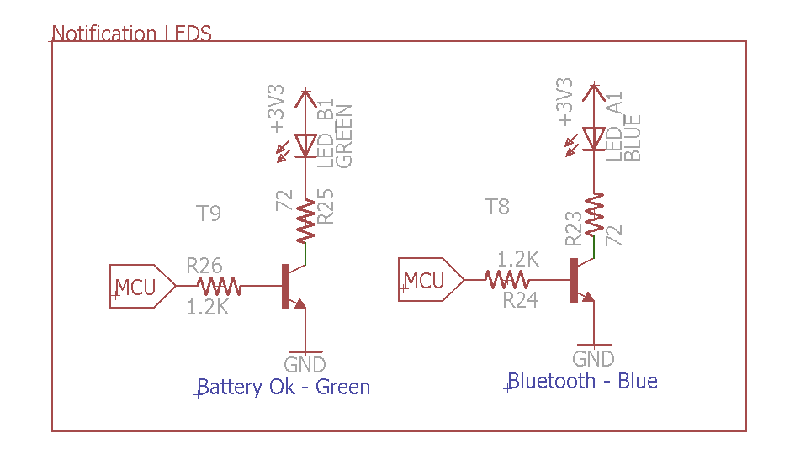

*Figure {*} Notification LEDs*

We measured the current flowing through each LED and found that the blue LED consumes 16.43mA, while the Green LED consumes a 5.53mA. Utilizing these currents as the emitter current of the 2N2222 transistor we can get the current at the base of the transistor. We utilize the same DC current gain of the provided in the calculation of the H-Bridge.

* + 1. **Buzzer**

**Accord**

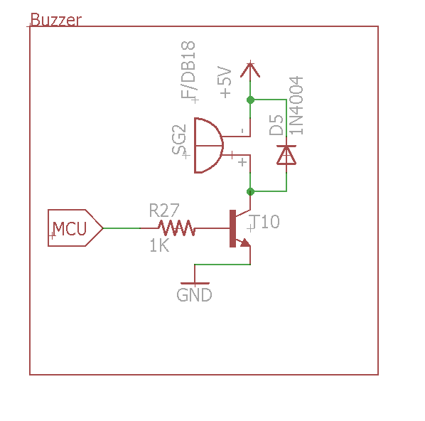

References

1. Solar Breeze cost: <https://www.amazon.com/Solar-Breeze-SOLARBREEZE-Robotic-Cleaner/dp/B00DK9H1C8/ref=sr_1_fkmr0_3?ie=UTF8&qid=1479573891&sr=8-3-fkmr0&keywords=sea+breeze+pool+cleaner>
2. Dunnrite skimmer cost: <https://www.amazon.com/Dunn-Rite-Skimmer-Remote-Control/dp/B004VQE4HE/ref=sr_1_sc_2?ie=UTF8&qid=1479573983&sr=8-2-spell&keywords=dunn+rite+pool+skimmer>
3. HC-SR04 Datasheet: <http://www.micropik.com/PDF/HCSR04.pdf>
4. MPU9250 Datasheet: <https://www.invensense.com/products/motion-tracking/9-axis/mpu-9250/>
5. MPU9250 Register Map: <https://cdn.sparkfun.com/assets/learn_tutorials/5/5/0/MPU-9250-Register-Map.pdf>
6. NIMH discharge: https://traxxas.com/forums/showthread.php?396271-How-much-should-I-discharge-a-NIMH
7. LM317t datasheet: <http://www.st.com/content/ccc/resource/technical/document/datasheet/group1/a0/db/e6/9b/6f/9c/45/7b/CD00000455/files/CD00000455.pdf/jcr:content/translations/en.CD00000455.pdf>

Datasheets:

1. HLS-T758 Relay: <http://www.kosmodrom.com.ua/pdf/HLS-T78.pdf>
2. 2N2222 NPN transistor: <http://www.onsemi.com/pub_link/Collateral/P2N2222A-D.PDF>
3. Resistance tolerances are 1% (Brown stripe)
4. 1N4001 Diode: <http://www.diodes.com/_files/datasheets/ds28002.pdf>
5. Blue, Greed LED: <http://www.cree.com/~/media/Files/Cree/LED-Components-and-Modules/HB/Data-Sheets/C503B-BAS-BAN-BCS-BCN-GAS-GAN-GCS-GCN-1094.pdf>

Appendix:

1. Economic analysis table
2. H-Bridge Schematics